Diabetes Prediction Model using Machine Learning
Prepared by: Rinad Odeh, Sara Domaidi
Supervised by: Adnan Salman

1. Summary
This project aims to build an artificial intelligence model capable of predicting diabetes in patients using biomedical data. The "Pima Indians Diabetes" (PIMA) dataset, which contains physiological indicators such as glucose levels and Body Mass Index (BMI), was utilized. The methodology relied on data preprocessing and cleaning to address non-sensical zero values through Median Imputation, followed by feature scaling to ensure algorithmic accuracy. Four models were tested: Logistic Regression, Random Forest, Support Vector Machine (SVM), and Gradient Boosting. The results indicated that Logistic Regression was the most stable in terms of the CV-F1 Score, while the SVM model excelled in its ability to detect positive cases (Recall).

2. Introduction

Motivation
Diabetes is classified as one of the most prevalent and dangerous chronic diseases in the modern era, representing a massive challenge to global healthcare systems. The danger of this disease lies in its long-term complications, which may include kidney failure, heart disease, and vision loss—especially if not diagnosed in its early stages. The primary motivation for this research is to harness Machine Learning (ML) techniques to provide a diagnostic support tool characterized by both accuracy and speed.
The importance of this project lies in shifting healthcare from "reactive" to "proactive." Instead of waiting for acute clinical symptoms to appear, computational models can analyze simple vital data to detect complex patterns indicating the likelihood of future infection. This not only helps save lives but also significantly reduces the financial costs associated with treating late-stage complications. Furthermore, providing a non-invasive tool based on routine laboratory measurements makes screening accessible to a larger segment of society.

Background
The PIMA Indians Diabetes Dataset is a cornerstone in diabetes prediction studies, originally collected by the National Institute of Diabetes and Digestive and Kidney Diseases in the United States. Historically, medical studies focused on analyzing each feature individually; however, Machine Learning has revolutionized the field through its ability to understand "cross-correlations" between multiple features simultaneously, such as the relationship between age, BMI, and insulin levels.
Our current work focuses on improving the accuracy of classical models through Data Engineering and Hyperparameter Tuning. The greatest challenge in such medical data is the presence of missing values or values incorrectly recorded as zeros, which we addressed meticulously to ensure model unbiasedness. We primarily focus on balancing performance between overall accuracy and the model's ability to not overlook any patient (clinically known as Sensitivity or Recall), ensuring maximum safety in diagnosis.

3. Dataset

Features Description
The dataset consists of 768 samples, each with 8 independent features influencing the final outcome:
- Pregnancies: Number of times pregnant; an indicator as gestational diabetes can increase permanent risk.
- Glucose: Plasma glucose concentration (2 hours in an oral glucose tolerance test); the most critical biochemical indicator.
- Blood Pressure: Diastolic blood pressure (mm Hg); high blood pressure is often linked to insulin resistance.
- Skin Thickness: Triceps skinfold thickness (mm), used to estimate body fat percentage.
- Insulin: 2-hour serum insulin (mu U/ml); indicates pancreatic efficiency.
- BMI: Body Mass Index (weight in kg/(height in m)$^2$); a primary measure of obesity related to diabetes.
- Diabetes Pedigree Function: A function that scores the genetic likelihood of diabetes based on family history.
- Age: A fundamental risk factor, as susceptibility increases with age.

Preprocessing
- Data Correction: Zeros in (Glucose, Blood Pressure, Skin Thickness, Insulin, BMI) were replaced with Median values, as zero is physiologically impossible in these contexts.
- Scaling: StandardScaler was used to normalize the data range, assisting algorithms like SVM and Logistic Regression in performing with higher efficiency.
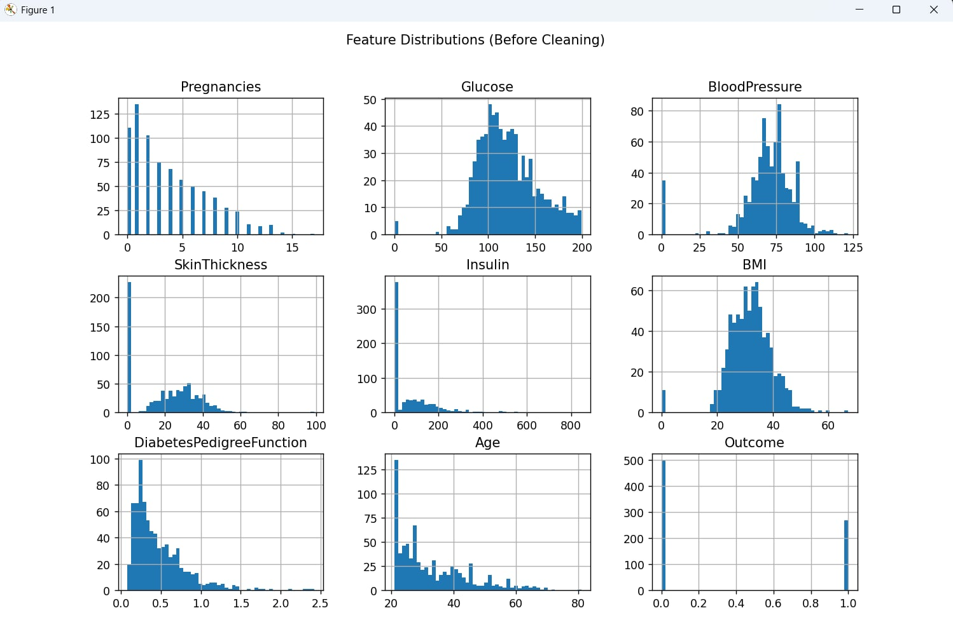
Figure 1. Distribution of Dataset Features Before Preprocessing.

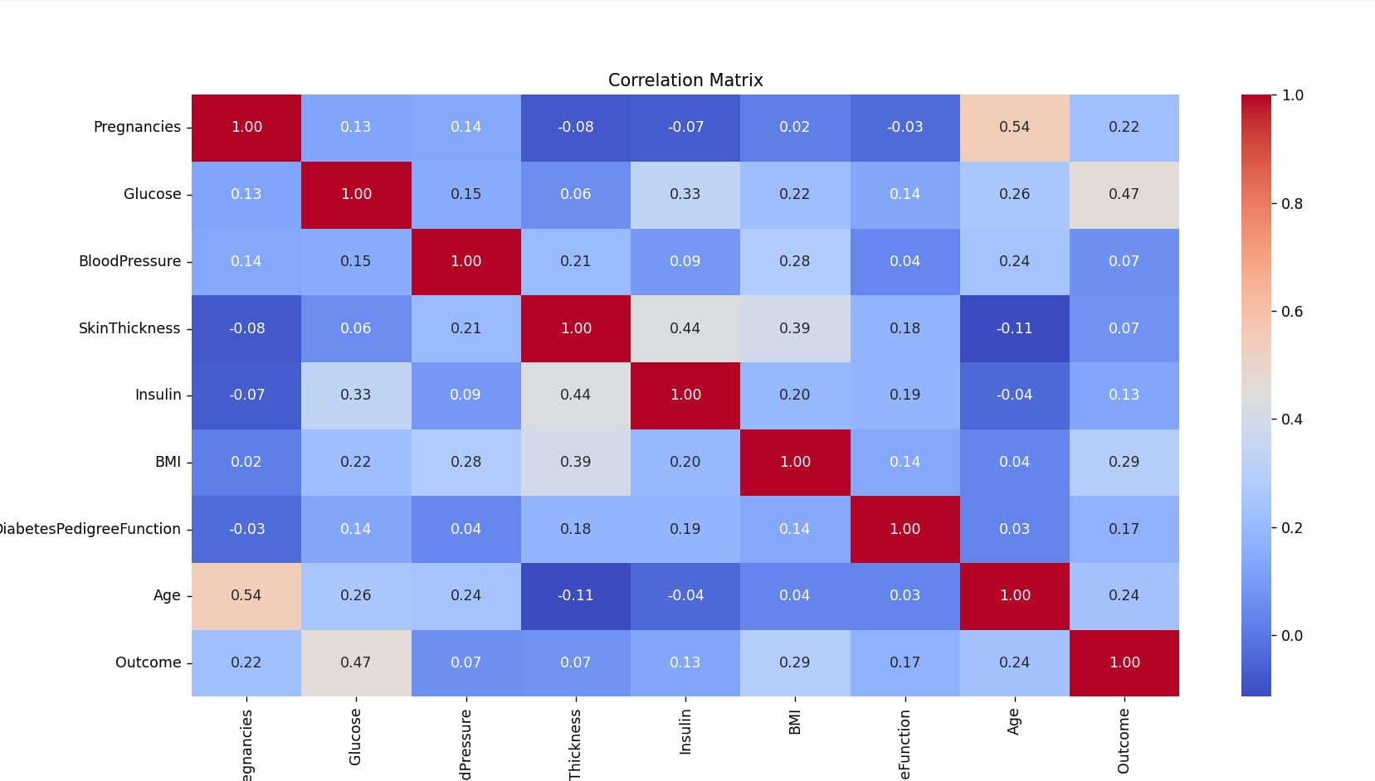
Figure 2. Correlation Matrix of Dataset Features.

4. Methodology
The methodology follows a comprehensive machine learning engineering approach, passing through organized stages to transform raw data into a reliable predictive model.

A. Data Engineering & Preprocessing
The methodology began with a critical data cleaning phase where "biological non-sensical zeros" were identified. Instead of deleting these samples, we applied Median Imputation to preserve data distribution. This was followed by Standard Scaling to rescale all features to a mean of 0 and a standard deviation of 1. This step is essential for distance-based algorithms like SVM and Logistic Regression, preventing features with large values (like Insulin) from dominating features with smaller numerical ranges.

B. Model Training Strategy
Data was split into 80% for training and 20% for testing using a Stratified Split. This ensures that the ratio of diabetic to healthy individuals in the test set is identical to the training set, preventing evaluation bias. Four diverse algorithms were selected:
- Logistic Regression: A baseline linear model known for speed and interpretability.
- Random Forest: An ensemble model based on decision trees to reduce overfitting.
- SVM: High capability in finding the optimal hyperplane between classes in complex spaces.
- Gradient Boosting: Performance enhancement by correcting errors of previous trees sequentially.

C. Hyperparameter Tuning via GridSearchCV
We utilized GridSearchCV to move beyond default settings. We conducted a comprehensive search across a "grid" of possibilities for each model (e.g., varying C in SVM or n_estimators in Random Forest). This was integrated with 5-Fold Cross-Validation, ensuring that the superiority of the selected model was a result of true performance stability.

Clinical Evaluation Criteria

As a medical project, priority was given to two metrics:
- F1-Score: The primary criterion for selecting the best model, representing the harmonic mean between Precision and Recall.
- Recall: Emphasized heavily (clearly seen in SVM's 77.78% performance) because the medical goal is to minimize "False Negatives"—ensuring no diabetic patient is told they are healthy.

Results

Findings
Based on the actual code output, the following table compares model performance after tuning:
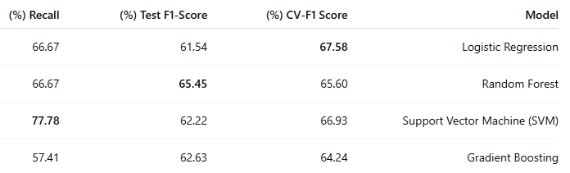
Figure 3.Performance Comparison of Machine Learning Models.
Note: Logistic Regression was selected as the best overall model based on stability (CV-F1), although SVM achieved the highest sensitivity (Recall) at 77.78%.
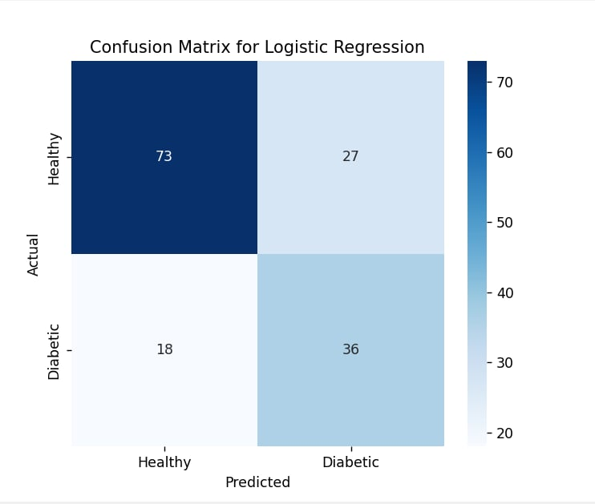
Figure 4. Confusion Matrix of the Optimized Classification Model.
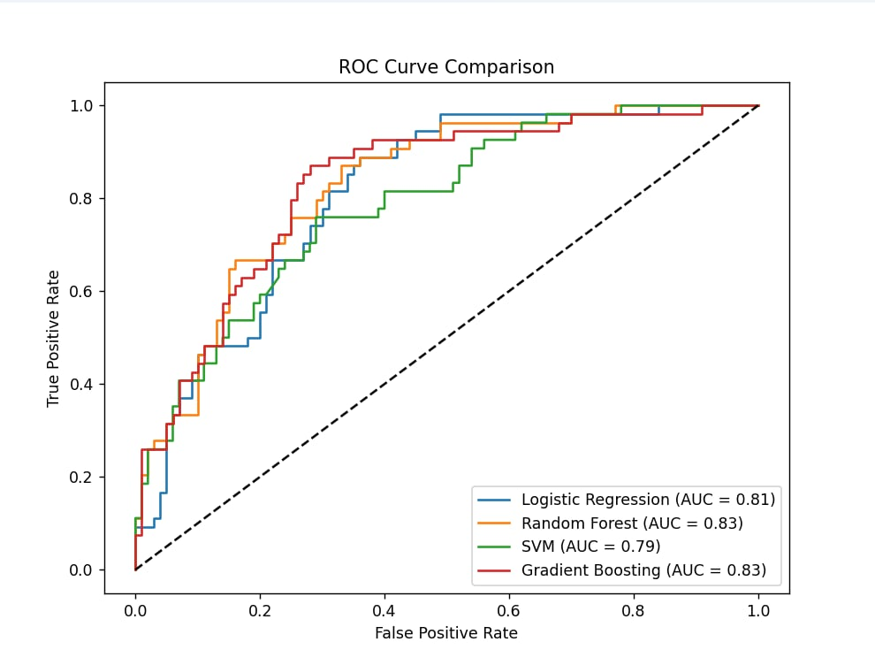Figure 5. Receiver Operating Characteristic (ROC) Curve.

Discussion
The results show that the model successfully predicted cases with acceptable accuracy; in one positive test case, the prediction probability reached 0.87. Data cleaning was decisive; the system's ability to catch invalid inputs (negative values), as seen in the code's error messages, enhances the model's clinical reliability.

6. Conclusion
This project demonstrates that integrating clinical indicators with machine learning provides a powerful tool for early diabetes detection. The experience was rich in learning how to handle missing data and the importance of selecting the right metric (F1 vs. Recall). We recommend increasing the dataset size in the future to improve the accuracy of complex models like Gradient Boosting, which typically perform better with larger samples.

7. References
- Smith, J. W., et al. (1988). Using the ADAP learning algorithm to forecast the onset of diabetes.
- Kaggle. Pima Indians Diabetes Database.
- Scikit-learn Documentation. GridSearchCV and Evaluation Metrics.

